**An Interactive Patient Portal to Enhance Patient-Provider Communications for Improved Healthcare Outcomes**

Report Number: **TR-CIS-0420-16**

Defense Date: 21st April 2017

By

Shreya Chakrabarti

March 2017

Submitted To

The Faculty of Purdue University  
 Dr. Yuni Xia  
 Dr.Xukai Zou  
 Dr.Wu Huanmei

In Partial Fulfillment of the

Requirement for the Degree

Of

**Master of Science in Computer & Information Science**

**May 2017**

**ACKNOWLEDGEMENTS**

This project has given me a wonderful opportunity to deeply understand the world of Healthcare and Real World application development curtailed towards patient healthcare requirements. I am very grateful to my advisor Dr. Yuni Xia for choosing me to work on this project.

I would like to thank my advisor and Dr. Huanmei for their guidance, support and excellent advice throughout this project.

I would also like to thank Dr. Xukai Zou for accepting to be part of my committee.

I deeply appreciate all the guidance and support received from all of you and my family while working for this project.

Shreya Chakrabarti

**ABSTRACT**

With the increasing power of the internet, it is now easier than ever to access the internet, over any device be it Phone, Tablet, Laptop or a Personal Computer. Being the most popular technology in the world’s history the most valuable contribution of the internet for me has been the revolution of communication system it has caused between any two parties.  
  
There are some industries which utilize the advantages of communication more than many others. One such example is Social Media platforms and apps like Facebook, Twitter and WhatsApp which have made use of this advantage to its maximal.  
  
However the same thing cannot be said about Healthcare industry. Although there are various patient portal’s which are used by Doctor’s practicing with bigger organizations like Franciscan, Community Health Network & Indiana Health. But there are very few portal’s which allow local healthcare practitioners with private dispensaries to have the same ease of communication with their respective patients.  
  
Also, these patient portals only allow for communication with other healthcare professionals like Doctors, Nurses and other health care practitioners within the same organization when the patient visits the hospitals. However, throughout my research for other patient portals I did not find any portal which gives the patient an opportunity to maintain record of his health when he is not visiting the Doctor or Nurse practitioner.

My objective behind development of this analytical patient portal was to utilize the advantages of other patient portals along with providing the patients a facility to record their temperature, blood-pressure, blood-sugar, weight & heartbeat and make them in charge of their own health.  
  
Along with providing the patients an interface to track their health, it also provides the Doctor’s with essential medical history of the patient which further helps the treatment of the patient.   
In addition to this the app also allows you to find a doctor with respect to the type of checkup needed, allows to schedule an appointment with the doctor, Use the portal to keep records of electronic reports for various scans, bloodwork etc. It also allows you to pay for Doctor’s appointments online.

For the above requirements, a project was developed with front-end as Ruby on Rails and AJAX & database used to store the data is SQLite. All the charts generated in the portal are via chart kick gem.

**TABLE OF CONTENTS**

1. **INTRODUCTION…………………………………………………….5**
   1. ***OBJECTIVE…………………………………………………………………6***
   2. ***PURPOSE OF THE WORK………………………...………………….…7***
   3. ***STATE OF THE WORK PROPOSED WORK………………………….7***
2. **METHODOLOGY**
   1. ***WORKSPACE DIAGRAM………………………………………………...8***
   2. ***WORKFLOW DIAGRAM………………………………………………...10***
   3. ***SOFTWARE……………………………………………………………….14***
   4. ***PROCEDURE……………………………………………………………16***
3. **RESULTS………………………………………………………….18**
4. **CONCLUSIONS…………………………………………………..32**
5. **CHALLENGES……………………………………………………33**
6. **FUTURE SCOPE.............................................................................34**
7. **REFERENCES................................................................................35**

**1. INTRODUCTION**

Healthcare is the maintenance or improvement of health via diagnosis, treatment and prevention of disease, illness, injury and other physical and mental impairments in human beings1. 100% of the doctors in the world would agree that right diagnosis would help in curing and maintaining patient health in a much better manner than it is done presently. Many of the ancient medical sciences practiced even today believe in diagnosis of present condition through Medical History, Ayurveda a medical practice from over a thousand years ago, is one such example.  
The age of internet along with its numerous advantages also brings disadvantages such as an increasingly sedentary lifestyle which include activities like [sitting](https://en.wikipedia.org/wiki/Sitting) or [lying](https://en.wikipedia.org/wiki/Lying_(position)), [reading](https://en.wikipedia.org/wiki/Reading_(process)), socializing, watching [television](https://en.wikipedia.org/wiki/Television), playing [video games](https://en.wikipedia.org/wiki/Video_game), and [mobile phone](https://en.wikipedia.org/wiki/Mobile_phone)/[computer use](https://en.wikipedia.org/wiki/Computer_use) for much of the day with little or no vigorous physical exercise2.   
It is this sedentary lifestyle which is leading cause to many of the preventable causes of death which include high risk illnesses like Anxiety, Cardiovascular disease, Migraines, Breast cancer, Colon cancer, Depression, Diabetes, Gout, High blood pressure, Lipid disorders, Skin problems such as hair loss, Mortality in adults, Obesity, Osteoporosis, Scoliosis, Spinal disc herniation (Low back pain)3 to name a few.  
To avoid these sedentary lifestyle’s side effects healthcare industry has come up with various tracking devices and app’s for motivation of movement like fitbit,googlefit and many others which allows users to log their steps taken during the day and also log other workouts they might do during the day . Also for heart patients, diabetic patients and high blood pressure patients there are now devices in the market which help them keep track of their vital numbers.  
However even when this monitoring is a type of medical history of the patient it hardly plays a role clinically. The reason for this is that tracking devices were meant for self-help and not to collect medical history. Having said that there have been numerous cases where people have detected something wrong with their heart rate via the tracking devices and have avoided fatal problems like a heart-attack.  
Some of the cases include an elderly person from Australia finding his heart rate in the dangerous zone on one such tracking device and rushing to the hospital before a fatal heart attack. In another incident, a teen from the UK found her heart rate to be 210beats per minute and rushed to the hospital in what doctors believe to be a lucky escape from fatal heart condition.  
Even though some in the medical community still believe that these medical devices do not provide the most accurate information but none of them deny that these devices help their patients stay motivated towards their health situation in general and keeps them alert of abnormality that they might see in their regular monitoring of this data.

Another problem faced by patients is to find a doctor who could cater to their needs best and have availability at the earliest. Doctor availability in the USA is a huge problem because of the lack of medical professionals and due to their busy schedules. There is an emerging evidence that lengthy waits to get a doctor’s appointment has become the norm in many parts of American medicine, particularly for general doctors but also for specialists4 . This wait can be harmful or beneficial depending on the circumstances.  
This problem has been tackled in the patient portal by allowing the patients to check for the next availability of the doctor they selected out of the listed doctors and book an appointment with the doctor at their earliest available timing. Patients would also know the preferred insurance by the doctor and send a private message to the doctor to check if the insurance they carry is accepted by the doctor.  
With the advent of cloud storage and functionalities like google drive it has become convenient for users to store important documents for easy access and longtime storage. Caching in on the ‘online generation’ Patient Portal allows users to store their medical reports like scans, blood reports and other important information online for their convenience and the convenience of their doctors for long term access to these records.  
As the online system has become robust about online payments with respect to security and convenience. The patient portal also offers the patients to pay for their appointments online with respect to the type of insurance they hold and doctor’s fees.

**1.1 Objective**

The objective of the project was to include individual health assessments in medical history and to inculcate the discipline of self-help in patients. These individual health assessments are recorded from health tracking devices patients might have at home for regularly monitoring of their health via Sphygmomanometer, Glucose meter, Thermometer, Weight Weighing machines and record their individual workouts.  
This step makes the patient more aware of their own vital values like resting heat rate or resting blood pressure and them to take the necessary action when the numbers fluctuate or reach alarming values.  
This self-discipline in the patients further inculcates ‘preventive health care ’ rather than emergency situations at a later stage and thus can help the doctor and the patient to be more responsible towards health of the patient.

**1.2 Purpose of the Work**

Effective doctor-patient communication is a central clinical function in building a therapeutic doctor-patient relationship, which is the heart and art of medicine. This is important in the delivery of high-quality health care. Much patient dissatisfaction and many complaints are due to breakdown in the doctor-patient relationship5. The purpose of developing this portal was to develop a better patient doctor relationship by giving the patient a chance towards the betterment of his/her health by providing them the access to store their health records monitored through various machines and provide them a drive type functionality for maintenance of reports etc. on the portal itself. The patient would thus possess details of their past physician details, past appointments, past reports and payment details online which can be easily accessed from anywhere in the world.

* 1. **State of the art proposed work**

The Patient Portal would be developed in Ruby on Rails with SQLite database for storing doctor and patient information. It will consist of the following pages:

* Registered doctors with their practice listed
* Ability for patients to schedule appointments with the physicians
* Ability for patients to store medical reports like blood-work, scans and other important reports related to their health on the portal in a drive like system
* Ability to pay for their appointments online

The project progressed in the following stages:

* Database diagram for the portal
* Choosing of the best suitable language for the development
* Development
* Testing
* Feeding Data to the system to check for robustness of the system

**2.1. METHODOLOGY**

**2.1 Workspace Diagram**

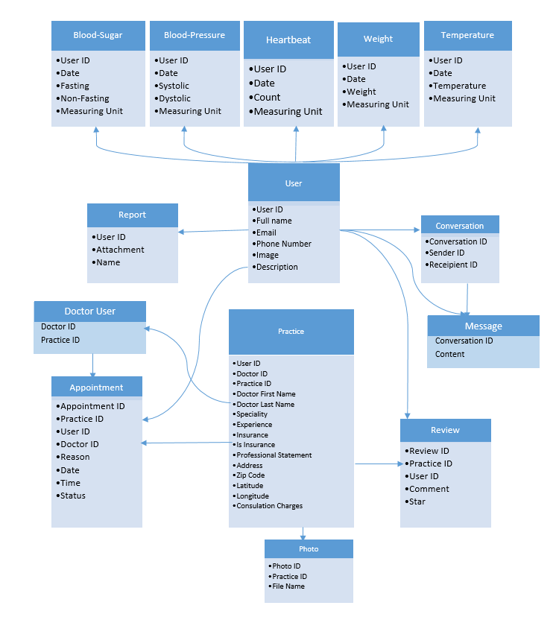

* Fig.1 shows a workspace model based on which the database required for the creation of the portal was created
* The workspace model shows that User table has references to all the tables in the database
* User Table consists of all the user information like user email, phone-number, full-name, description and an avatar associated with it
* User Table also consists of all the information required by ‘Devise’ and ‘O-Authentication’ gems required for logging the user into the portal
* Practice table mostly belongs to the Doctors who would list their practices on the portal
* Appointments table is a connection between practice and user table, as any of the registered user can create an appointment with the doctor for his/her listed practices
* Similarly, a user can review a practice listed by Doctor only if she/he has ever had an appointment with the doctor
* Also, only a user who has posted the review can delete the review and not the doctor for whom the review was posted
* The photos table was provided for the doctors to provide information about their specialty or the treatments they offer in their practices therefore it is linked only with the practice table
* As the portal offers the functionality to chat between doctors and patients to check for other information it has a conversation model which records the sender and receiver id along with assigning the conversation id listed for the message
* The message model associated with this conversation consists of the content of the messages exchanged between two users
* The several types of vitals like heartbeat, blood-pressure, blood-sugar, weight and temperature have their own models as each of them would act like a form to record input from the user
* The drive to be created for users to record their lab reports has a separate model as it would consist of all the reports uploaded by the user

**2.2 WORKFLOW DIAGRAM**

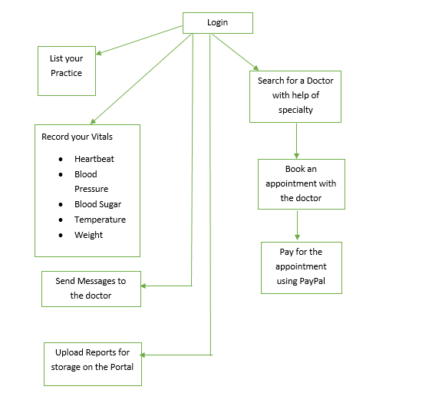

**Fig.2 Workflow Diagram**

Figure above shows the workflow diagram of the portal developed during this project.   
The portal was developed to cater to patient needs and improve patient communication with their health care team.

Any kind of registration on the portal requires a user to login into the portal.

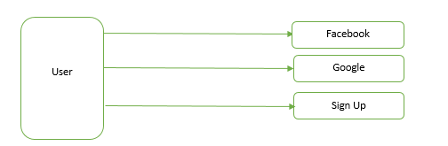

**Fig.3 Options for user to login**

Portal offers three ways to register into the portal

* Facebook
* Google
* Normal Registration using Sign Up to the portal

Facebook and Gmail authorizations were created for the portal for user convenience. These functionalities were incorporated in the portal using developer portals offered by Facebook & Google.  
  
In case a user is a doctor, she/he can list their practices on the portal based on their specialty and location, years of experience and a carousel of pictures which allows the practitioners to advertise his clinic, practice based on the kinds of treatments offered by the practitioner’s model also includes a description field describing the practitioner’s work over his years of practice.

Appointment’s model allows another user who is registered on the portal to book an appointment with the practitioners of her/his choice based on the specialty and location the user is looking for.

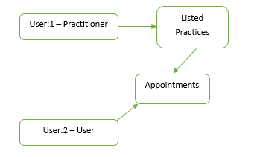  
 **Fig.4 Making Appointments**

Users can schedule appointments with doctors for any one of their listed practices and pay for the appointment using PayPal’s online payment system.

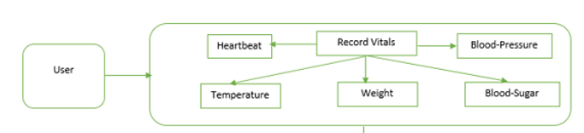

**Fig.5 Uploading Vitals**

Above figure shows the workflow to record vital values like temperature, heartbeat, weight, blood pressure and blood sugar. This is the main feature of the project and therefore includes a sophisticated way for the users to keep track of their health by displaying charts of the various values entered by the patient over different dates.

If the user enters value of same vital on the same day the system takes average of the two values entered. This feature keeps the patients motivated to keep their health in the recommended ranges by the doctor.

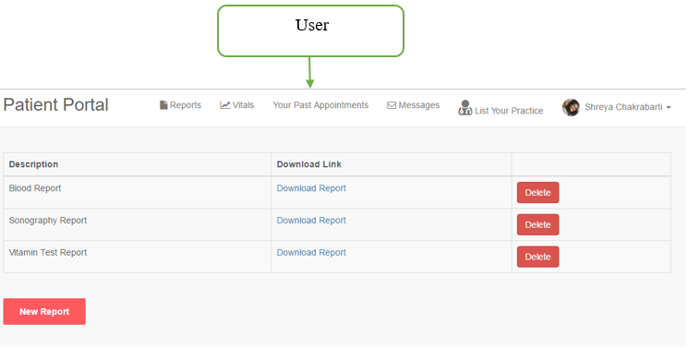

**Fig.5 Uploading Reports**

Since the world is increasingly moving towards cloud storage, the patient portal offers functionality for the patients to upload all the pathological reports and reports for various scans that a patient might go through during the span of his life.

The idea behind this feature was to provide long time electronic storage of records for patients.

**2.2 Software**

The software selected for the development of this application is Ruby on Rails with its default database setting of SQLite. Rails was selected because it is a web application development framework written in Ruby language.  
The major advantage of Rails is that it uses the MVC (model-view-controller) pattern which allows users to avoid repetitive tasks in the development process.

Model–View–Controller (MVC) is a [software architectural pattern](https://en.wikipedia.org/wiki/Architectural_pattern) for implementing [user interfaces](https://en.wikipedia.org/wiki/User_interface) on computers. It divides a given application into three interconnected parts in order to separate internal representations of information from the ways that information is presented to and accepted from the user8.  
The MVC used in the development of this app works in the following way:

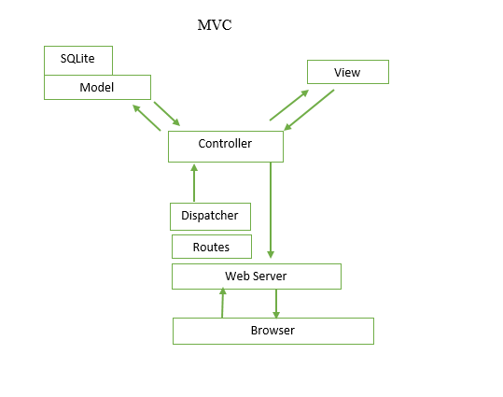

**Fig.7 Understanding of the Model used for Development**

The figure can be explained as below:

* Browser makes request for the webpage in this case: <https://patientportalfinal-shreya19888.c9users.io>
* The webserver (WEBrick) receives the request and looks for routes for the requested request. The web server then uses the dispatcher to create a new controller, call the action and pass the parameters
* Controller’s in the MVC are the managers which are responsible for parsing user requests, data-submissions, cookies and sessions. An example scenario can be given as user makes request to view a doctor’s profile the show method in the controller knows the user is looking for the doctor’s profile it asks the model to get the profile and displays it to the requesting user
* Models are basically responsible for crunching numbers. They talk to the database, store and validate data and perform business logic
* Views are user’s view of the entire system

In the simplest of language, the 3-tier architecture of the MVC model can be explained as Controllers to be the masterminds behind the system, views to be the face of the system and models to be the brain behind the system responsible for data processing and grunting.

In addition to the development language and database used for the development of the portal. Cloud9 integrated development environment.   
Cloud9 supports hundreds of programming languages, including C, C++, PHP, Ruby, Perl, Python, JavaScript with Node.js, and Go. It enables developers to get started with coding immediately with pre-configured workspaces, collaborate with their peers with collaborative coding features, and web development features like live preview and browser compatibility testing.9  
Cloud9 development environment was chosen for the ease of pre-configured workspaces in cloud accessible from anywhere in the world with any OS system. Also, Cloud9 offers support for code repositories such as GitHub for code storage and retrieval for later use.  
The development environment also offers support for deployment of the application to Heroku for making the application publicly available.

**2.3 Procedure**

The following steps were the steps involved in Development of the portal:

* Requirements Gathering:

With the increasing sedentary lifestyles amongst the current world population there is a hoard of lifestyle related diseases. The below infographic from lifespanfitness.com gives the glimpse of the problems associated with sedentary lifestyle:

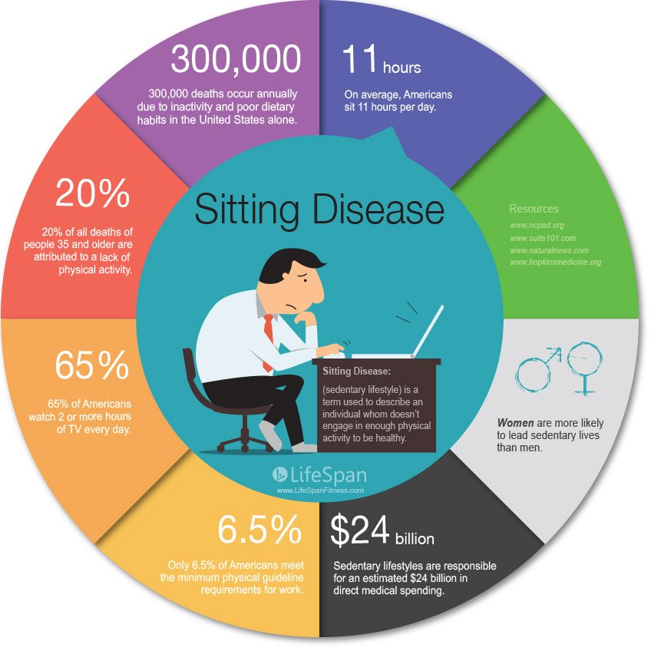

**Fig.8 Sedentary Lifestyle10**

Although avoiding a sedentary lifestyle is an obvious solution all the problems listed above. There are also scenarios where these diseases are hereditary or caused due to other causes other than sedentary lifestyle.

With the advancement in technology more and more advanced medical instruments are being developed which would keep track of the various vital values that might help avoid a fatal situation of health.

However, the data collected by these instruments is not included in the health history monitored by doctor’s. Thus, it was decided to include these vitals in the patient side of the portal as this might give the patients an extra layer of control over their health other than regular check-ups with the doctor. Although, Doctor might decide on not using this data for medical purposes but it helps in keeping the patient motivated towards maintenance of their health.  
  
 In addition to this for patient’s convenience it other facilities like scheduling, paying for appointments and storing reports online was also included.

* Software Selection:

Ruby on Rails was selected as it is a web application framework and it was suitable for the development needs of the project.  
Cloud9 IDE offers all the software requirements required for the development process already installed without occupying any memory on the local machine. Also, as Rails is a software more catered to be suited on Mac system OS, on Cloud9 it does not matter about the OS installed on the local machine.

* Development Process:

As the development was carried out in MVC supported environment all the models mentioned in Fig.1 were generated according to the database requirements of each model. These models are then connected to each other as per the requirements of the project.   
Model acts as the structure of the system, View is the display of the structure and controller is the brain of the of the system. Each model follows this process.

* Data

Data was created to test the various scenarios and requirements of the portal. This data of 50 listed practitioners and 100 registered users were created manually using the dashboard registration system.

**3. Results**

**Authentication Page**

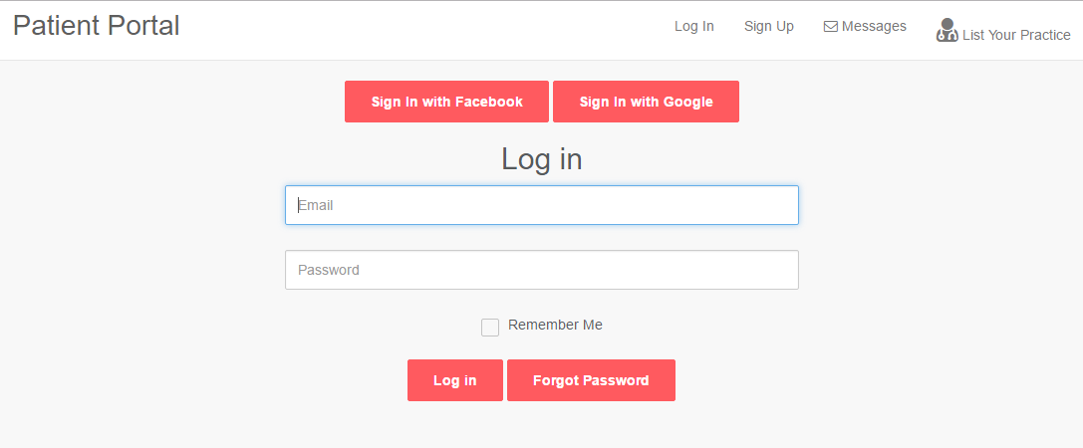

**Fig.9 Login Page**

The authentication page on the portal which allows the user to register into the portal using Facebook, Google or normal sign up process.

**Homepage**

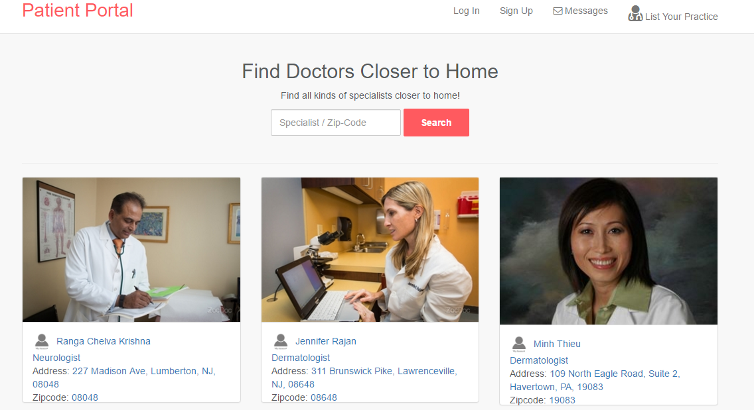 **Fig.10 Homepage**

Homepage displaying the list of various doctors registered on the website and offering numerous services on the portal. Homepage also has a search function which allows the user to search for a doctor in his/her area or search a doctor as per the doctor’s specialty.

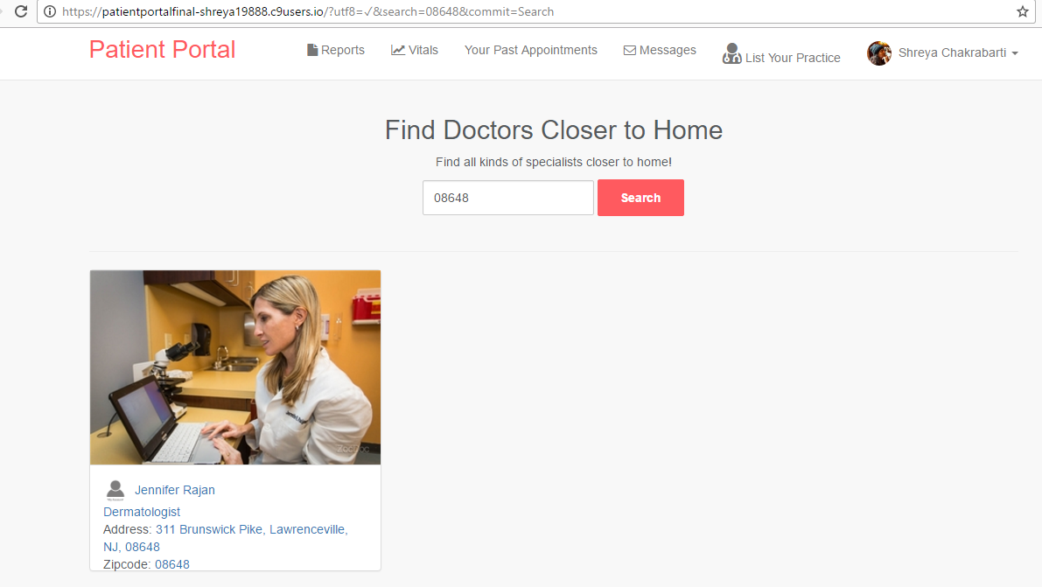  
 **Fig.11 Working of Search Function using Zip Code**

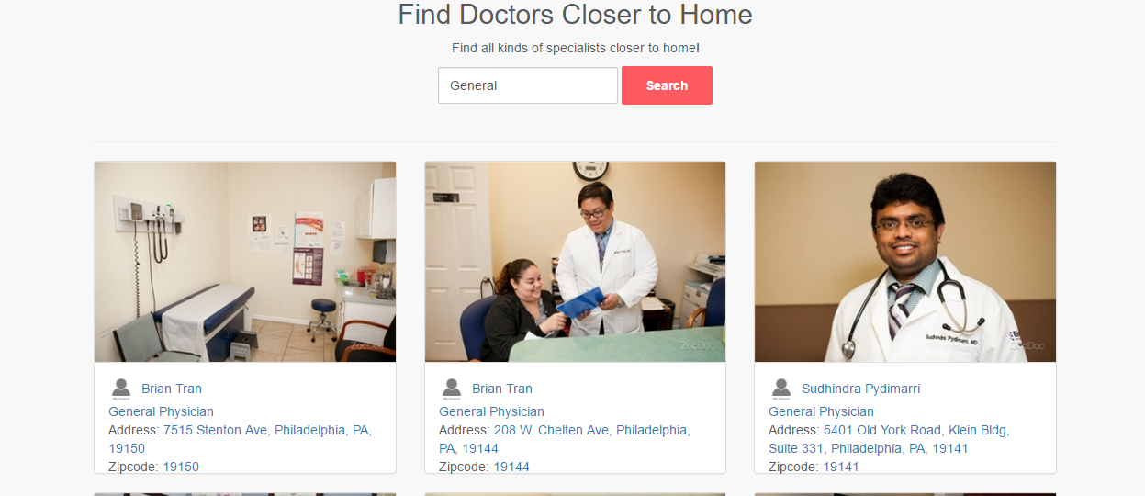

**Fig.12 Working of Search Function using Doctor’s Specialty**

**Doctor Listing and Appointment booking**

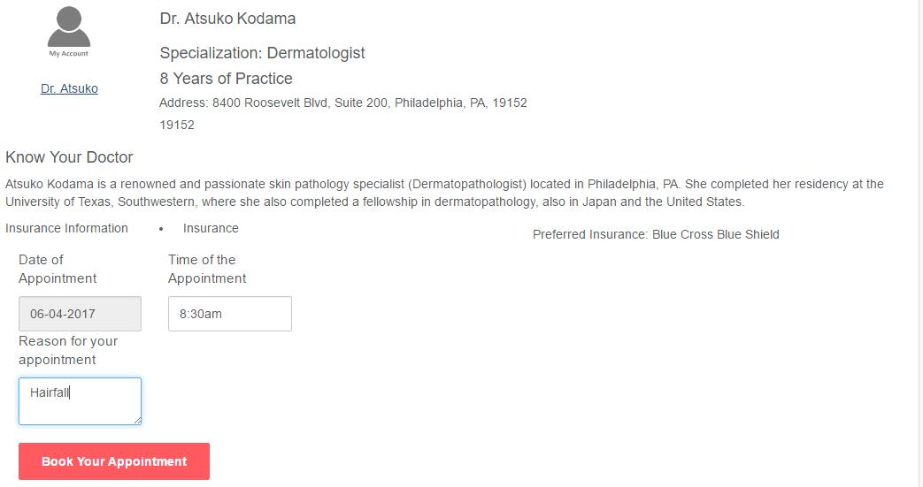

**Fig. 13 Doctors Profile**

Once the patient is sure of the services he is looking for he can click on the doctor’s listing and book the appointment he/she desires.

The appointment can be booked by providing Date, Time and a reason for the appointment.  
Once the book appointment is clicked the patient can pay for his/her appointment as below  
  
Once the appointment is booked the portal also allows the patient to leave a review for the doctor’s services as described in the payment system embedded into the website using Paypal.

**Payment for the Appointment**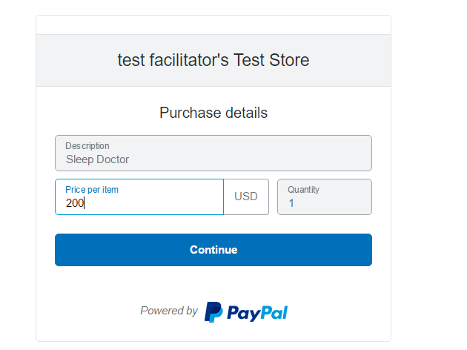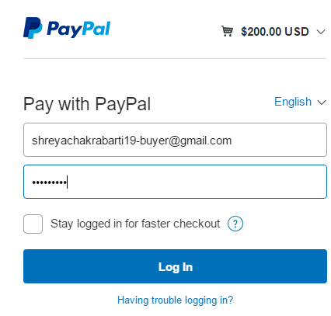

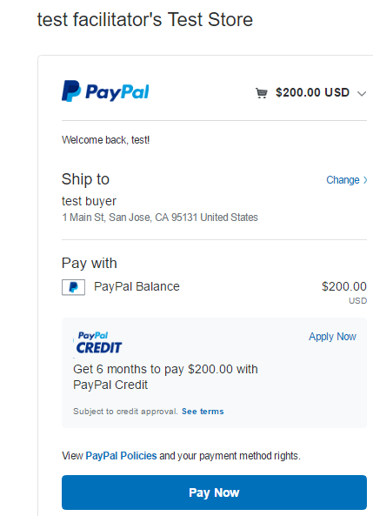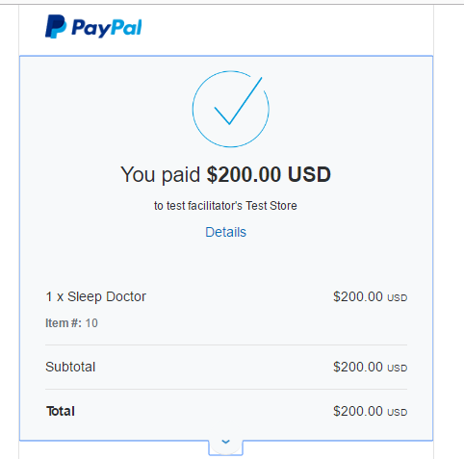

**Fig.13 PayPal**

As soon as the appointment is confirmed the patient can make the payment for the appointment via PayPal system.

**Appointment Schedule**

Patient can view the scheduled appointment under your appointments tab:  
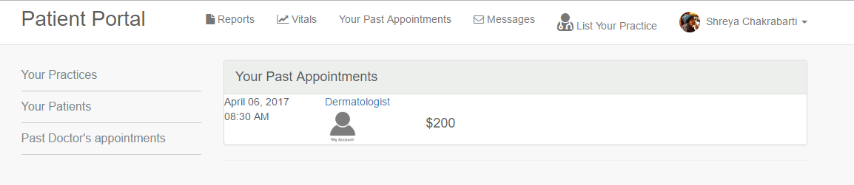

**Fig.14 Appointments Schedule**

Also the doctor can view the scheduled appointment under your patients   
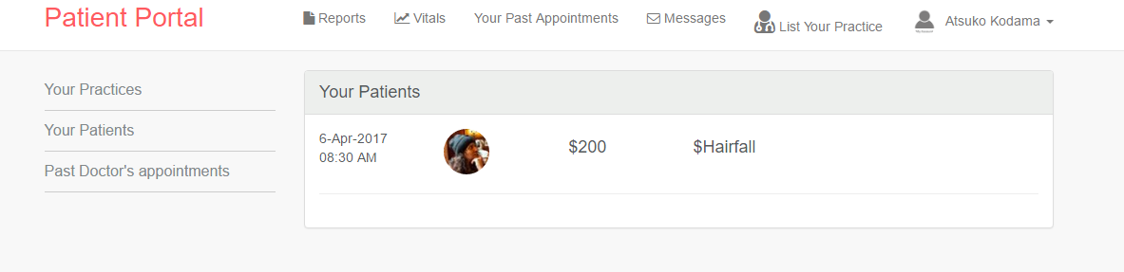

**Fig.15 Doctors View of the Appointment**

If another patient tries to book an appointment on the same date and time he/she gets the below message:  
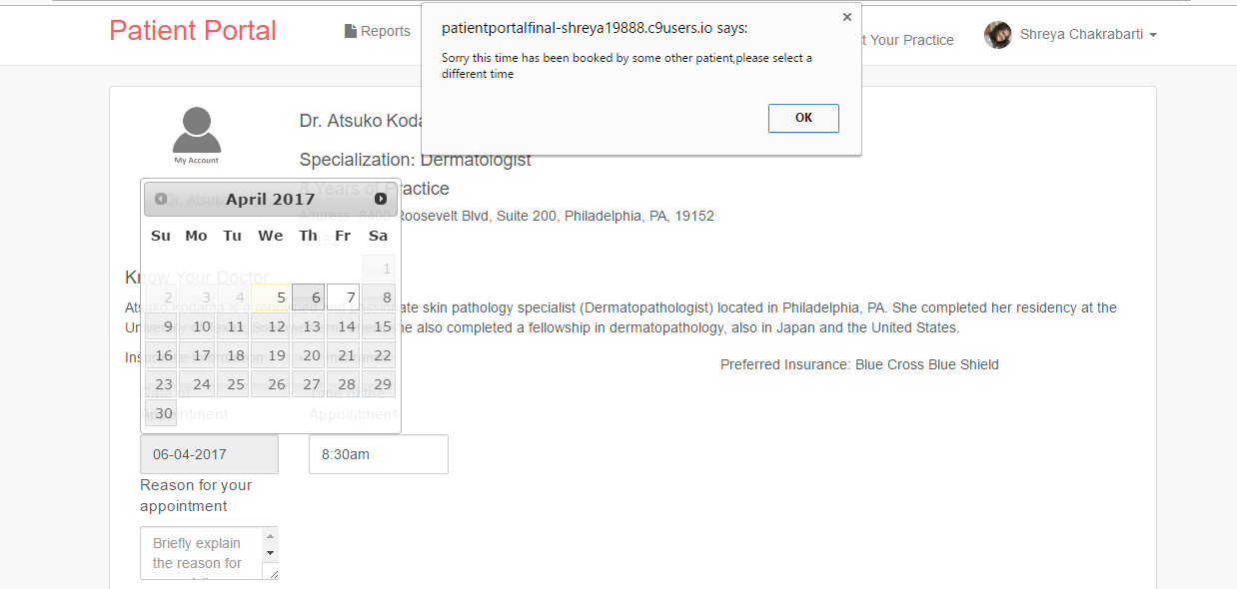

**Fig.16 Appointment Conflict**

The message “Sorry this time and date has been booked by some other patient” is used to warn other patients of an appointment conflict and requests them to choose a different time of the same day or a different date.

**Other Features of Doctors Profile**

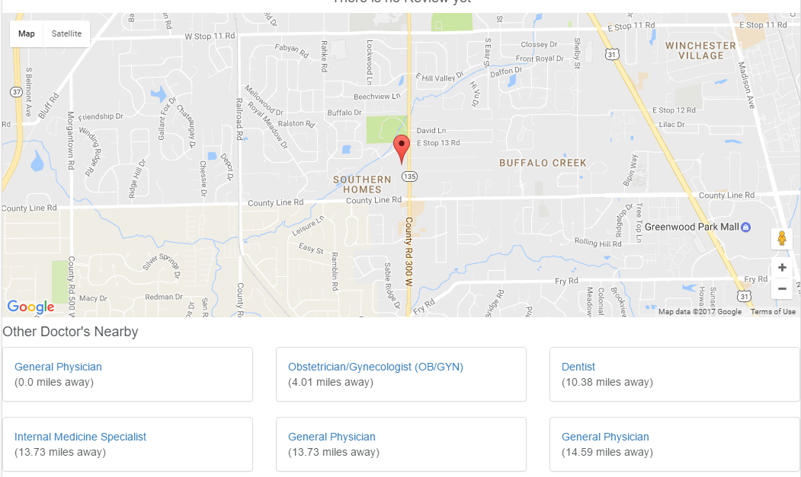

**Fig.17 Map and Nearby Doctor’s**

Doctor’s profile also highlights the Doctors location on a map and also provides other doctor’s within a 10 miles radius to the particular doctor’s location who’s profile is being viewed by the future patient.

This feature allows the patients to know the landmarks around doctor’s office as well as take care of their other medical needs by scheduling appointments with other specialists close by to this doctor.

**Chat with Doctor**

A Patient can chat with the doctors listed on the portal by using the embedded chatting system

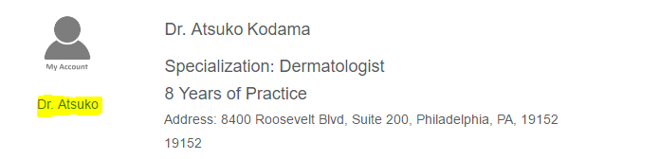

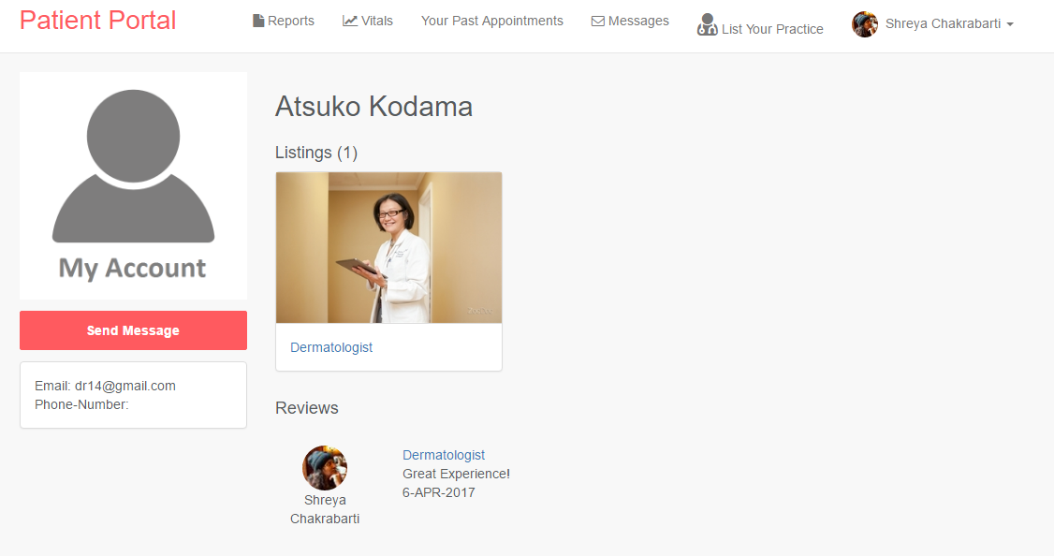

**Fig.18 Contact Details**

On clicking the profile button the user is taken to the doctor’s profile where he would find doctor’s email address and phone number along with a functionality to send the doctor message.

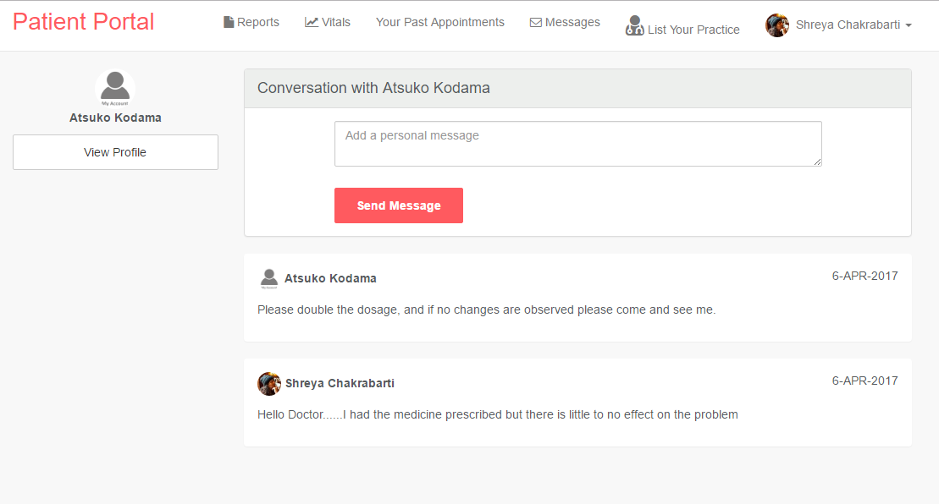

**Fig.19 Chat with Doctor**

The patient can send messages to the doctor and doctor can respond to the queries via the messaging system. Additionally the doctor can also send messages to the patient after the appointment has been scheduled.  
Doctors can also send messages to other doctor’s by viewing other doctor’s profiles as well.  
This functionality helps doctors to get consultations about other fields other than their own specialty. This further improves doctors networking and communication with their respective patients.

**Review**

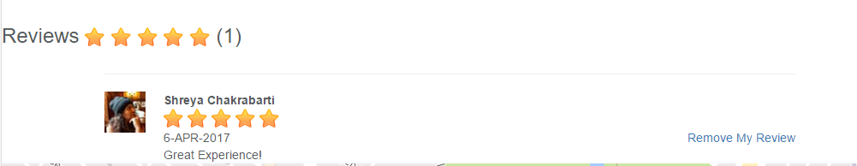

**Fig.20 Review for Doctor**

Once a user has booked an appointment with a doctor he/she can leave a review about the doctor’s services. Additionally, only that user has the functionality to remove the particular review but any other user can just read the review. The stars besides the Reviews will provide an average of all the reviews available for the doctor.

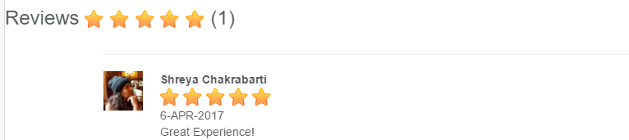

**Fig.21 Different User’s view of the review**

**Vitals Upload**

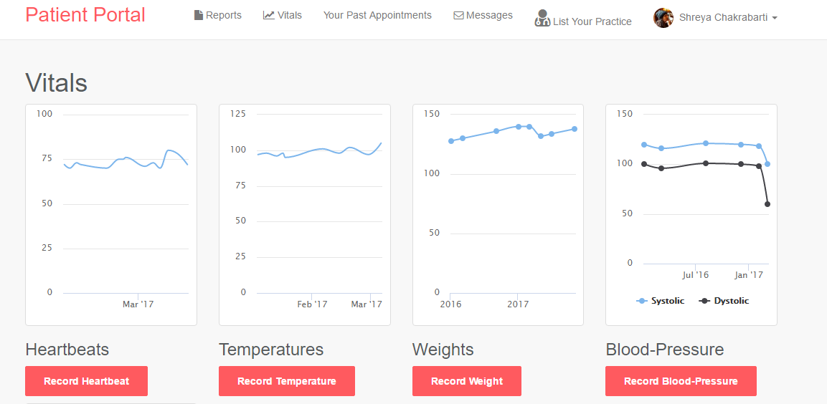

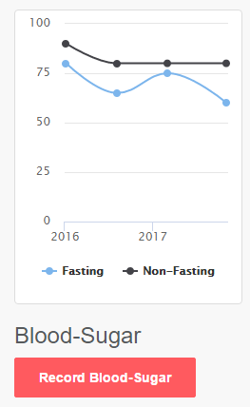

**Fig.22 Vitals Upload**

Vitals upload is the most important feature of the portal. This dashboard offers the patient to upload their own vitals on the portal using various advanced medical instruments available in the market like:

* Glucose Meter – Blood glucose (blood sugar) is an essential measure of your health. People with Diabetes and High Blood Sugar diseases have an issue with their Blood Sugar levels being consistently high. Over time, this can damage their body and lead to many other problems, this is the reason why Doctor’s suggest that Blood Sugar levels of such patients should be monitored every day. This feature to record the blood sugar available in the portal allows patients to be aware of his health condition instead of awaiting a fatal result to occur.
* Sphygmomanometer- Blood pressure is measured with an instrument called a sphygmomanometer. If your blood pressure is high, it is putting extra strain on your arteries and on your heart. Over time, this strain can cause the arteries to become to become thicker and less flexible, or to become weaker. If your arteries become thicker and less flexible, they will become narrower, making them more likely to become clogged up. If an artery becomes completely clogged up (known as a clot), this can lead to a heart attack, a stroke, kidney disease or dementia11.Similarly, even moderate forms of low blood pressure can cause not only dizziness and weakness but also fainting and a risk of injury from falls. And severely low blood pressure from any cause can deprive your body of enough oxygen to carry out its normal functions, leading to damage to your heart and brain12.Therefore doctor’s advice patients of Hypertension and Hypotension to monitor their blood pressure regularly. This feature to record the blood pressure available in the portal allows patients to be aware of his health condition instead of awaiting a fatal result to occur.
* Heart Beat Monitor- The resting heart rate is how fast your heart beats outside of any physical activity, when all your heart must do is keep your basic body functions running. It is also an excellent indicator of your overall fitness. Outside of any specific ailment, a lower resting heart rate correlates very closely to a state of greater general fitness and health. On the other hand, a high resting heart rate increases the risk of heart attack and can be indicative of a predisposition for diabetes and obesity13. The heart rate monitor on the portal gives an idea to the patient about increase or decrease in his/her heartbeat which is measured in beats per minute in the available monitors in the market. This can keep the patient aware of his increasing resting heart rate and in turn motivate him/her to start being physically active.  
  This monitor can also be used by heart patients who have recently faced an episode of heart related ailments for the observation of proper functioning of the heart.
* Obesity- Obesity is a complex disorder involving an excessive amount of body fat. Obesity isn't just a cosmetic concern. It increases your risk of diseases and health problems, such as heart disease, diabetes and high blood pressure. Being extremely obese means you are especially likely to have health problems related to your weight14.Keeping one’s weight in check not only avoids innumerous health problems but also provides an individual with immense confidence and helps develop his/her personality. The graph displayed on the portal after one track’s his/her weight is a motivation factor for an individual to increase or reduce his/her weight as required.
* Temperature – While technically, yes, all human [bodies are programmed to be 98.6 degrees Fahrenheit](http://www.youbeauty.com/health/ask-a-scientist-why-are-some-people-always-hot-and-some-always-cold/), the reality is that most of us experience small deviations from that temperature in either direction, for a wide variety of reasons, from diet to health disorders. There are also times when we may feel hotter or colder than usual, even though our actual core body temperature remains steady. Often, this must do with how hot or cold our extremities are — the temperature of our hands and feet often determine how we perceive our body's entire temperature to feel. [Women in general tend to feel colder than men](https://www.bustle.com/articles/81092-why-am-i-always-cold-6-reasons-you-might-feel-frozen-all-the-time), for example, even though our cores are often warmer, because estrogen can keep our blood from properly circulating through our hands and feet 15. The temperature measure on the website which was mainly incorporated for patients to monitor body temperatures when they have flu can also be useful in conditions of Hyperthyroidism where the body is hotter than usual or Cold Intolerance.

This functionality makes a person more aware of his/her own vital values and in turn he/she becomes more aware when he should be alarmed or relaxed with respect to his/her own health.

**Customizable Vital**

Patient can add a customizable vital field and enter the value of this vitals along with the date

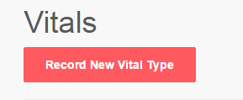

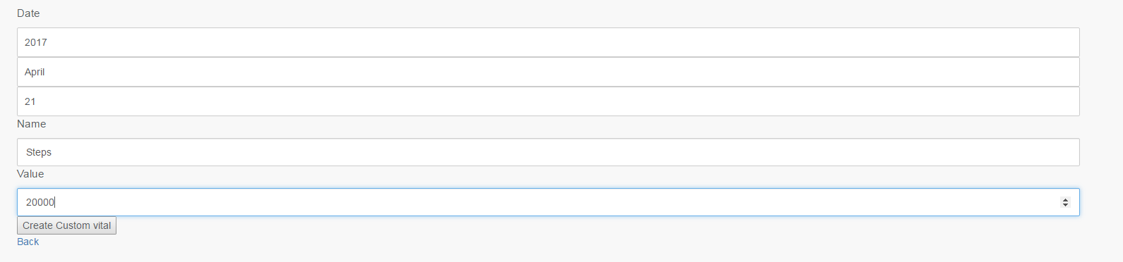

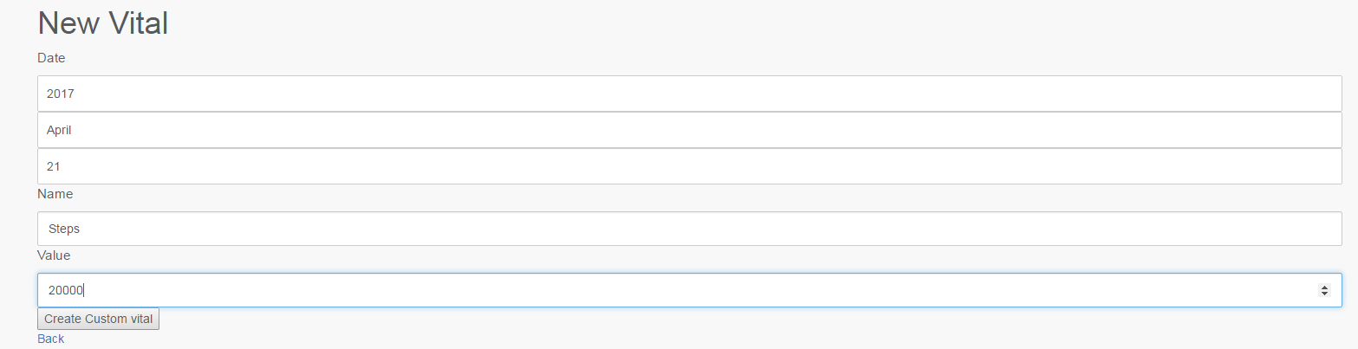

This feature was added so that if a particular patient wants to monitor his steps or any other vital not available by default in the vitals field he can monitor the same with the help of this customizable vital field.

**Report Listing Functionality**

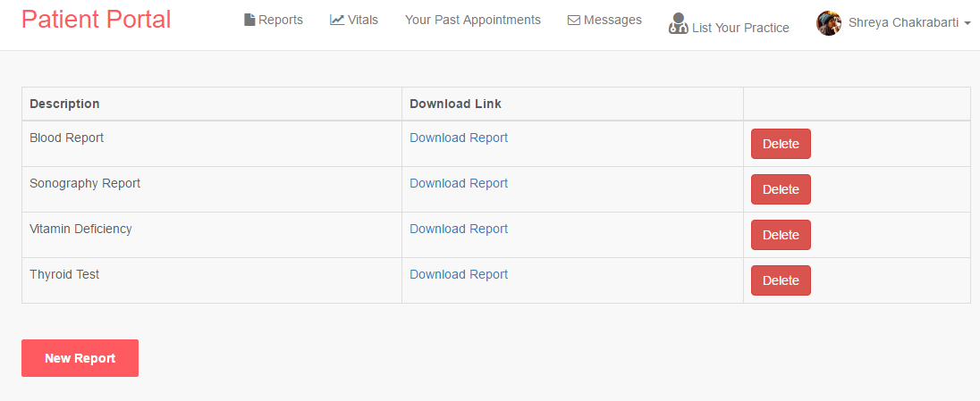

**Fig.23 Report Storage**

The report storage functionality offered on the website is more of a drive storage functionality which allows users to upload their pathological reports or MRI, PET scan reports online for future reference from anywhere in the world.

**Doctors View**

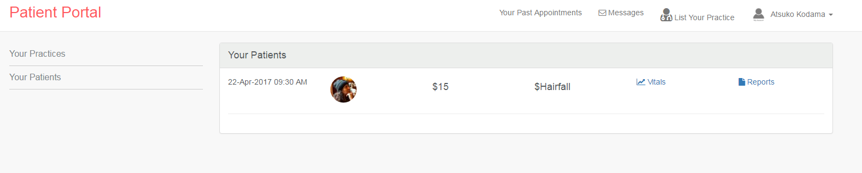

Any user logged in as a doctor can see the patients who have scheduled an appointment as above.  
This Doctor can further access the patient’s vital information and reports page to view the information entered by the patient.  
  
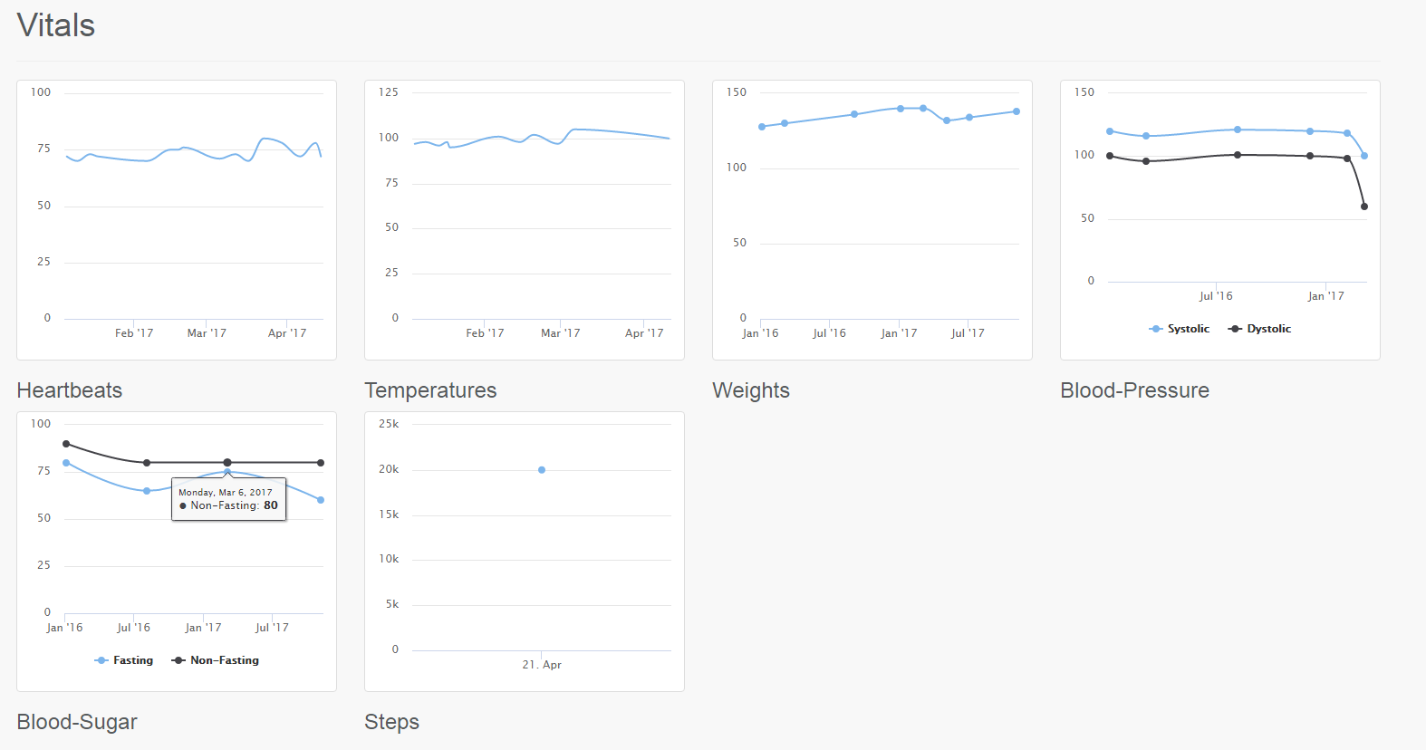

Additionally the doctor can check the patient’s reports to check for any contingencies before the patients visit.

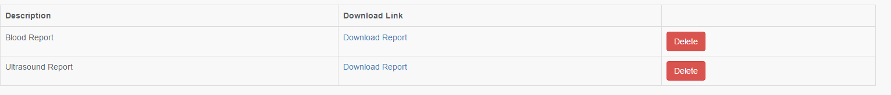

The Doctor would not have an ability to delete the patient’s reports but can view them by downloading.

**4. Conclusions**

The Patient portal developed in this project have unique features like:  
  
1) Providing a search engine for doctor’s specialty and zip code wise

2) Appointment scheduling facility as per doctor’s availability, avoiding appointment conflict

3) Rate a doctor’s services thus providing other patients a review and idea of a doctor’s seriousness towards his/her profession

4) Messaging facility within doctors and patients which allows doctors to network in their community and better communication with the patients

5) Provides Users to record their own vitals thus giving them an idea of their own health and motivation to improve the same

6) On like cloud-like storage Facility for storage of Reports

**5. Challenges**

There were many challenges faced while developing this portal namely:

1. Programming Language – Had to learn ruby on rails and all its functionalities from scratch as I was completely unaware of this language.

The language was earlier chosen as this was a team project earlier and one of the team members had worked a lot with this language. But later the team member dropped out of the project and the portal had to be completely developed from scratch by me with little to no experience in Ruby

1. Gems – Rails offers gems for integration of different functionalities for software development. Although this makes the job easy, finding the gems perfectly suited for the functionality needed and implementing them correctly was a challenge
2. Data – As there was no real data available for the portal all the data inserted had to be inserted manually thinking about different testing scenarios. Data was collected from one of the
3. Implementation of features like cloud storage and pulling data from a user’s Google Fit/Fitbit account was attempted but it was later found that this kind of implementation is not approved by the host websites themselves currently. But these hosts have plans of releasing the same in their upcoming releases

**6. Future Scope**

Some of the future work that can be done on the portal:

1. Cloud Integration: The reports which user tries to store could be uploaded in a secure Cloud Space with a higher space for storage of high quality sonography, PET and MRI scans
2. Google Fit/Fitbit Data: Although I did try to pull Google fit or Fitbit Data into the system using Developer API keys the unavailability of this feature made it impossible for me to do so. This feature will allow the user to check for his/her activeness by even checking his/her diet plans and steps measured by fitness app’s and fitness activity trackers like Fitbit
3. Involvement of a healthcare institution in testing: A healthcare institution or a clinic feedback on the system might help the system to become more robust and user specific.

7. **References**

<http://www.hoovers.com/company-information/cs/competition.franciscan_alliance_inc.525c07966f8cb347.html>

<https://au.news.yahoo.com/a/30839939/life-saving-fitbit-detects-grandfathers-heart-attack-before-it-happened/>

<https://betterexplained.com/articles/intermediate-rails-understanding-models-views-and-controllers/>

Figures:

|  |  |
| --- | --- |
| Fig.1 | **ERD Diagram** |
| Fig.2 | **Workflow Diagram** |
| Fig.3 | **Options for user to login** |
| Fig.4 | **Making Appointments** |
| Fig.5 | **Uploading Vitals** |
| Fig.6 | **Uploading Reports** |
| Fig.7 | **Understanding of the Model used for Development** |
| Fig.8 | **Sedentary Lifestyle** |
| Fig.9 | **Login Page** |
| Fig.10 | **Homepage** |
| Fig.11 | **Working of Search Function using Zip Code** |
| Fig.11 | **Appointment Booking** |
| Fig.12 | **Working of Search Function using Doctor’s Specialty** |
| Fig.12 | **Reviews** |
| Fig.13 | **Doctors Profile** |
| Fig.14 | **Appointments Schedule** |
| Fig.15 | **Doctors View of the Appointment** |
| Fig.16 | **Appointment Conflict** |
| Fig.17 | **Map and Nearby Doctor’s** |
| Fig.18 | **Contact Details** |
| Fig.19 | **Chat with Doctor** |
| Fig.20 | **Review for Doctor** |
| Fig.21 | **Different User’s view of the review** |
| Fig.22 | **Vitals Upload** |
| Fig.23 | **Report Storage** |

Citations:

|  |
| --- |
| 1 <https://en.wikipedia.org/wiki/Health_care> |
| 2 <https://en.wikipedia.org/wiki/Sedentary_lifestyle> |
| 3<https://en.wikipedia.org/wiki/Sedentary_lifestyle> |
| 4 <https://www.nytimes.com/2014/07/06/sunday-review/long-waits-for-doctors-appointments-have-become-the-norm.html?_r=0> |
| 5 <https://www.ncbi.nlm.nih.gov/pmc/articles/PMC3096184/> |
| 6 <https://www.ncbi.nlm.nih.gov/pubmed/18999115> |
| 7 <https://en.wikipedia.org/wiki/RubyGems> |
| 8 <https://en.wikipedia.org/wiki/Model%E2%80%93view%E2%80%93controller> |
| 9 <https://en.wikipedia.org/wiki/Cloud9_IDE> |
| 10 <https://www.lifespanfitness.com/workplace/resources/articles/sitting-all-day-is-taking-a-toll-on-your-body> |
| 11 <http://www.bloodpressureuk.org/microsites/u40/Home/facts/Whyitmatters> |
| 12 <http://www.mayoclinic.org/diseases-conditions/low-blood-pressure/basics/complications/con-20032298> |
| 13 <https://blog-admin.withings.com/2013/03/20/why-is-it-important-to-monitor-your-resting-heart-rate-2/> |
| 14 <http://www.mayoclinic.org/diseases-conditions/obesity/basics/definition/con-20014834> |
| 15 <https://www.bustle.com/articles/82394-why-am-i-always-hot-7-reasons-you-might-feel-like-the-roof-is-always-on> |

Development References:

<https://www.udemy.com/>

<https://code4startup.com/>

<https://www.youtube.com/>

<https://github.com/>